Contents

Folder Structure: 2

SOURCE CODE FOR SHOWING AND HIDING MODAL: 2

App.js 2

Modal.js 3

Modal.css 4

List.js 4

List.css 5

Backdrop.js 6

Backdrop.css 6

USING CSS TRANSITIONS 7

USING CSS ANIMATIONS 8

CSS TRANSTIONS AND ANIMATIONS LIMITATIONS 9

USING ReactTransitionGroup 11

react-transition-group 13

App.js [animation and transition, removing elements in DOM] 15

USING THE TRANSITION COMPONENT 15

WRAPPING THE TRANSITION COMPONENT [Nested loop] 16

ANIMATIONS TIMING 17

TRANSITIONS EVENTS 19

THE CSSTRANSITION COMPONENT 19

CUSTOMIZING CSS CLASSNAMES 22

ANIMATING LISTS 22

ALTENATIVE ANIMATIONS PACKAGES 24

- React-Motion Animation 24

- React Move 24

- React router transition 24

# Folder Structure:

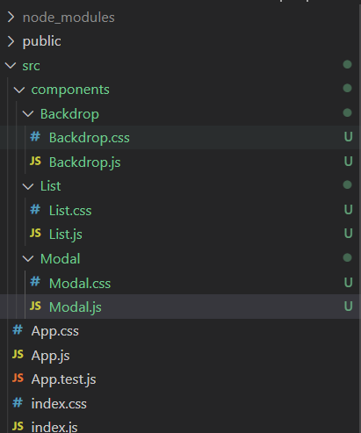

# SOURCE CODE FOR SHOWING AND HIDING MODAL:

## App.js

import React, { Component } from "react";

import "./App.css";

import Modal from "./components/Modal/Modal";

import Backdrop from "./components/Backdrop/Backdrop";

import List from "./components/List/List";

class App extends Component {

//6. Step to handle open and close

  state = {

    modalIsOpen: false

  }

  showModal = () => {

    this.setState({modalIsOpen: true});

  }

  closeModal = () => {

    this.setState({modalIsOpen: false});

  }

  render() {

    return (

      <div className="App">

        <h1>React Animations</h1>

        <Modal show={this.state.modalIsOpen} closed={this.closeModal}/>//7. Sending show and closed as props

        <Backdrop show={this.state.modalIsOpen} /> // 8.

        <button className="Button" onClick={this.showModal}>Open Modal</button>

        <h3>Animating Lists</h3>

        <List />

      </div>

    );

  }

}

export default App;

## Modal.js

import React from "react";

import "./Modal.css";

const modal = props => {

  const cssClasses = [

    "Modal",

    props.show ? "ModalOpen" : "ModalClosed"

  ];//4. step

  return (

    <div className={cssClasses.join(' ')}> //5. step

      <h1>A Modal</h1>

      <button className="Button" onClick={props.closed}>

        Dismiss

      </button>

    </div>

  );

};

export default modal;

## Modal.css

.Modal {

    position: fixed;

    z-index: 200;

    border: 1px solid #eee;

    box-shadow: 0 2px 2px #ccc;

    background-color: white;

    padding: 10px;

    text-align: center;

    box-sizing: border-box;

    top: 30%;

    left: 25%;

    width: 50%;

}

// 1. FOR MODAL CLOSE AND OPEN

.ModalOpen {

    display: block;

}

.ModalClosed {

    display: none;

}

## List.js

import React, { Component } from 'react';

import './List.css';

class List extends Component {

    state = {

        items: [1, 2, 3]

    }

    addItemHandler = () => {

        this.setState((prevState) => {

            return {

                items: prevState.items.concat(prevState.items.length + 1)

            };

        });

    }

    removeItemHandler = (selIndex) => {

        this.setState((prevState) => {

            return {

                items: prevState.items.filter((item, index) => index !== selIndex)

            };

        });

    }

    render () {

        const listItems = this.state.items.map( (item, index) => (

            <li

                key={index}

                className="ListItem"

                onClick={() => this.removeItemHandler(index)}>{item}</li>

        ) );

        return (

            <div>

                <button className="Button" onClick={this.addItemHandler}>Add Item</button>

                <p>Click Item to Remove.</p>

                <ul className="List">

                    {listItems}

                </ul>

            </div>

        );

    }

}

export default List;

## List.css

.List {

    list-style: none;

    margin: 0 auto;

    padding: 0;

    width: 280px;

}

.ListItem {

    margin: 0;

    padding: 10px;

    box-sizing: border-box;

    width: 100%;

    border: 1px solid #521751;

    background-color: white;

    text-align: center;

    cursor: pointer;

}

.ListItem:hover,

.ListItem:active {

    background-color: #ccc;

}

## Backdrop.js

import React from 'react';

import './Backdrop.css';

const backdrop = (props) => {

    const cssClasses = ['Backdrop', props.show ? 'BackdropOpen' : 'BackdropClosed']; //3. Open and closing on basis of props passed

    return <div className={cssClasses.join(' ')}></div>;//3. Joining css

};

export default backdrop;

## Backdrop.css

.Backdrop {

    position: fixed;

    z-index: 100;

    top: 0;

    left: 0;

    width: 100%;

    height: 100%;

    background-color: rgba(0,0,0,0.8);

}

//2. FOR OPEN AND CLOSE

.BackdropOpen {

    display: block;

}

.BackdropClosed {

    display: none;

}

# USING CSS TRANSITIONS

NOTE: display property in css prevents your transition or animations.

Modal.css

.Modal {

    position: fixed;

    z-index: 200;

    border: 1px solid #eee;

    box-shadow: 0 2px 2px #ccc;

    background-color: white;

    padding: 10px;

    text-align: center;

    box-sizing: border-box;

    top: 30%;

    left: 25%;

    width: 50%;

    transition: all 0.3s ease-out;

    /* ease-out : how to display */

}

.ModalOpen {

    /* display: block; */

    opacity: 1;

    transform: translateY(0);

}

.ModalClosed {

    /* display: none; */

    opacity: 0;

    transform: translateY(-100%);

}

# USING CSS ANIMATIONS

Modal.css

.Modal {

    position: fixed;

    z-index: 200;

    border: 1px solid #eee;

    box-shadow: 0 2px 2px #ccc;

    background-color: white;

    padding: 10px;

    text-align: center;

    box-sizing: border-box;

    top: 30%;

    left: 25%;

    width: 50%;

    transition: all 0.3s ease-out;

}

.ModalOpen {

    display: block;

    animation: openModal 0.3s ease-out forwards;

}

.ModalClosed {

    display: none;

    animation: closeModal 4s ease-out forwards;

}

@keyframes openModal {

    0% {

        opacity: 0;

        transform: translateY(-100%);

    }

    50% {

        opacity: 1;

        transform: translateY(90%);

    }

    100% {

        opacity: 1;

        transform: translateY(0);

    }

}

@keyframes closeModal {

    0% {

        opacity: 1;

        transform: translateY(0);

    }

    50% {

        opacity: 0.8;

        transform: translateY(60%);

    }

    100% {

        opacity: 0;

        transform: translateY(-100%);

    }

}

# CSS TRANSTIONS AND ANIMATIONS LIMITATIONS

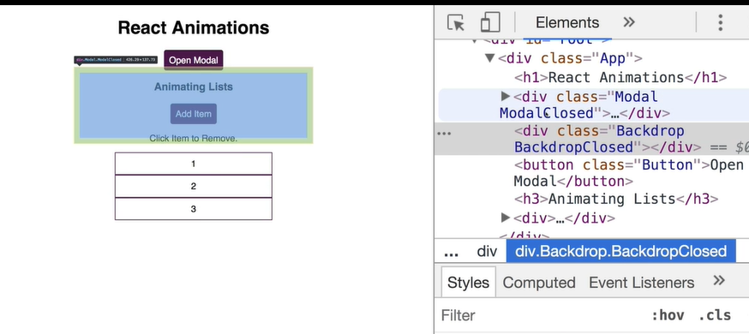

ModalClosed and ModalOpened are always in ou DOM which is not best.

App.js

import React, { Component } from "react";

import "./App.css";

import Modal from "./components/Modal/Modal";

import Backdrop from "./components/Backdrop/Backdrop";

import List from "./components/List/List";

class App extends Component {

  state = {

    modalIsOpen: false

  }

  showModal = () => {

    this.setState({modalIsOpen: true});

  }

  closeModal = () => {

    this.setState({modalIsOpen: false});

  }

  render() {

    return (

      <div className="App">

        <h1>React Animations</h1>

        {this.state.modalIsOpen ? <Modal show={this.state.modalIsOpen} closed={this.closeModal}/> : null}

        {this.state.modalIsOpen ? <Backdrop show={this.state.modalIsOpen} /> : null}

        <button className="Button" onClick={this.showModal}>Open Modal</button>

        <h3>Animating Lists</h3>

        <List />

      </div>

    );

  }

}

export default App;

It will remove Modal when it is closed in DOM.

# USING ReactTransitionGroup

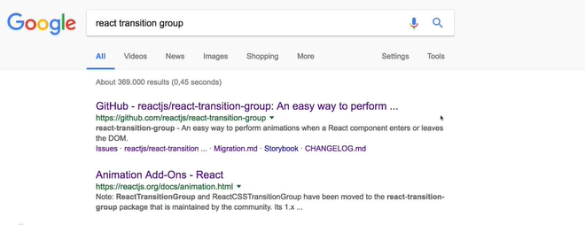

INSTALL: npm install react-transition-group –save

App.js

import React, { Component } from "react";

import "./App.css";

import Modal from "./components/Modal/Modal";

import Backdrop from "./components/Backdrop/Backdrop";

import List from "./components/List/List";

class App extends Component {

  state = {

    modalIsOpen: false,

    showBlock: false

  }

  showModal = () => {

    this.setState({modalIsOpen: true});

  }

  closeModal = () => {

    this.setState({modalIsOpen: false});

  }

  render() {

    return (

      <div className="App">

        <h1>React Animations</h1>

        <button onClick={() => this.setState(prevState =>({showBlock: !prevState.showBlock}))}>Toggle</button>

        {

          this.state.showBlock ?

          <div style={{

            backgroundColor: 'red',

            width:100,

            height:100

          }}>

          </div> : null

        }

        {this.state.modalIsOpen ? <Modal show={this.state.modalIsOpen} closed={this.closeModal}/> : null}

        {this.state.modalIsOpen ? <Backdrop show={this.state.modalIsOpen} /> : null}

        <button className="Button" onClick={this.showModal}>Open Modal</button>

        <h3>Animating Lists</h3>

        <List />

      </div>

    );

  }

}

export default App;

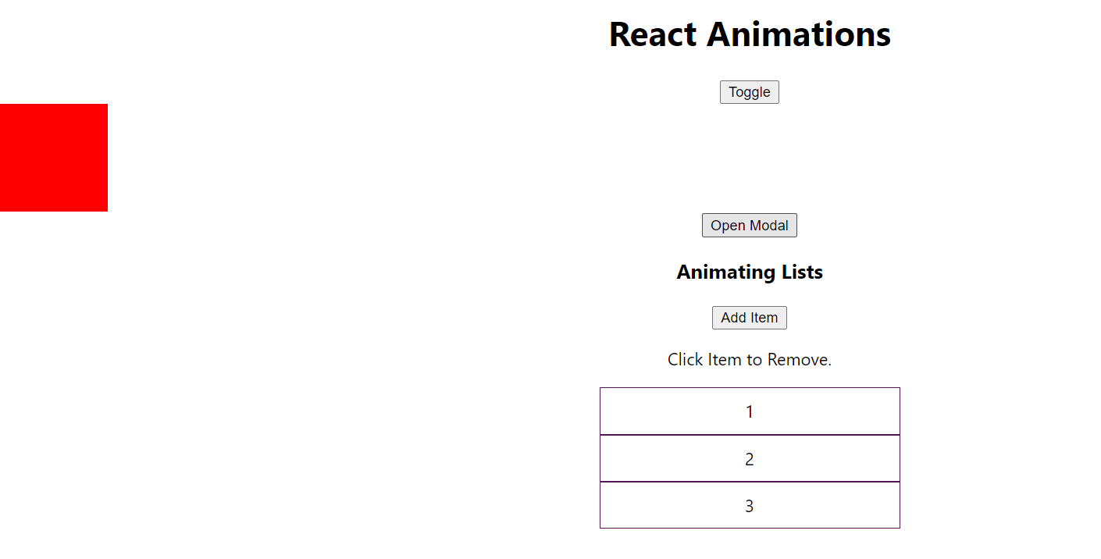

{

          this.state.showBlock ?

          <div style={{

            backgroundColor: 'red',

            width:100,

            height:100,

            margin:'auto'

          }}>

Margin auto to place in center.

## react-transition-group

App.js

import React, { Component } from "react";

import { Transition } from 'react-transition-group';

import "./App.css";

import Modal from "./components/Modal/Modal";

import Backdrop from "./components/Backdrop/Backdrop";

import List from "./components/List/List";

class App extends Component {

  state = {

    modalIsOpen: false,

    showBlock: false

  }

  showModal = () => {

    this.setState({modalIsOpen: true});

  }

  closeModal = () => {

    this.setState({modalIsOpen: false});

  }

  render() {

    return (

      <div className="App">

        <h1>React Animations</h1>

        <button

        onClick={() => this.setState(prevState =>({showBlock: !prevState.showBlock}))}>

        Toggle

        </button>

        <Transition

          in={this.state.showBlock}

          timeout={300}>

          {state => <p>{state}</p>}

        </Transition>

        {this.state.modalIsOpen ? <Modal show={this.state.modalIsOpen} closed={this.closeModal}/> : null}

        {this.state.modalIsOpen ? <Backdrop show={this.state.modalIsOpen} /> : null}

        <button className="Button" onClick={this.showModal}>Open Modal</button>

        <h3>Animating Lists</h3>

        <List />

      </div>

    );

  }

}

export default App;

CONSOLE: CLICK ON TOGGLE BUTTON

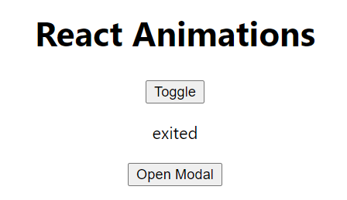

## App.js [animation and transition, removing elements in DOM]

<Transition

        in={this.state.showBlock}

        timeout={300}

        mountOnEnter

        unmountOnExit

        >

        {state =>(

          <div style={{

            backgroundColor: 'red',

            width:100,

            height:100,

            margin:'auto',

            transition: 'opacity 1s ease-out',

            opacity: state === 'exiting' ? 0: 1

          }} />

          )

         }

          </Transition>

# USING THE TRANSITION COMPONENT

App.js

        {/* FOR MODAL  */}

        <Transition

          in={this.state.modalIsOpen}

          timeout={300}

        >

          {state => (

            //rendering modal

            <Modal show={state} closed={this.closeModal}/>

          )}

        </Transition>

Modal.js

const modal = props => {

  const cssClasses = [

    "Modal",

    props.show  === 'entering'

    ? "ModalOpen"

    : props.show === 'exiting' ? "ModalClosed": null

  ];

# WRAPPING THE TRANSITION COMPONENT [Nested loop]

CUT AND PASTE <Transition> …</Transition> IN MODAL.JS

App.js

}

          </Transition>

          <Modal show={this.state.modalIsOpen} closed={this.closeModal}/>

        {this.state.modalIsOpen ? <Backdrop show={this.state.modalIsOpen} /> : null}

Modal.js

import React from "react";

import "./Modal.css";

import Transition from 'react-transition-group/Transition';

const modal = props => {

  return (

    <Transition

      mountOnEnter

      unmountOnExit

      in={props.show}

      timeout={300}

    >

    {state => {

      const cssClasses = [

        "Modal",

        state === "entering"

        ? "ModalOpen"

        : state === "exiting" ? "ModalClosed" : null

      ];

      return (

        <div className={cssClasses.join(' ')}>

        <h1>A Modal</h1>

        <button className="Button" onClick={props.closed}>

          Dismiss

        </button>

        </div>

      );

    }}

    </Transition>

  );

};

export default modal;

# ANIMATIONS TIMING

Modal.js

import React from "react";

import "./Modal.css";

import Transition from 'react-transition-group/Transition';

const animationTIming= {

  enter: 400,

  exit: 1000

}

// millisecond

const modal = props => {

  return (

    <Transition

      mountOnEnter

      unmountOnExit

      in={props.show}

      timeout={animationTIming}

    >

    {state => {

      const cssClasses = [

        "Modal",

        state === "entering"

        ? "ModalOpen"

        : state === "exiting" ? "ModalClosed" : null

      ];

      return (

        <div className={cssClasses.join(' ')}>

        <h1>A Modal</h1>

        <button className="Button" onClick={props.closed}>

          Dismiss

        </button>

        </div>

      );

    }}

    </Transition>

  );

};

export default modal;

Modal.css

.ModalClosed {

    display: none;

    animation: closeModal 1s ease-out forwards;

}

# TRANSITIONS EVENTS

App.js

<Transition

        in={this.state.showBlock}

        timeout={300}

        mountOnEnter

        unmountOnExit

        onEnter= { () => console.log("onENter")}

        onEntering={ () => console.log("onENtering")}

        onEntered={ () => console.log("onENtered")}

        onExit= { () => console.log("onExit")}

        onExiting= { () => console.log("onExiting")}

        onExited = { () => console.log("onExited")}

        >

# THE CSSTRANSITION COMPONENT

Modal.js

import React from "react";

import "./Modal.css";

import CSSTransition from 'react-transition-group/CSSTransition';

const animationTIming= {

  enter: 400,

  exit: 1000

}

// millisecond

const modal = props => {

  return (

    <CSSTransition

      mountOnEnter

      unmountOnExit

      in={props.show}

      timeout={animationTIming}

      classNames="fade-slide"

    >

    {/* fade-slide-enter

    fade-slide-exit-active */}

    {state => {

      const cssClasses = [

        "Modal",

        state === "entering"

        ? "ModalOpen"

        : state === "exiting" ? "ModalClosed" : null

      ];

      return (

        <div className="Modal">

        <h1>A Modal</h1>

        <button className="Button" onClick={props.closed}>

          Dismiss

        </button>

        </div>

      );

    }}

    </CSSTransition>

  );

};

export default modal;

modal.css

@keyframes openModal {

    0% {

        opacity: 0;

        transform: translateY(-100%);

    }

    50% {

        opacity: 1;

        transform: translateY(90%);

    }

    100% {

        opacity: 1;

        transform: translateY(0);

    }

}

.fade-slide-enter {

}

.fade-slide-enter-active {

    animation: openModal 0.3s ease-out forwards;

}

.fade-slide-exit {

}

.fade-slide-exit-active {

    animation: closeModal 1s ease-out forwards;

}

@keyframes closeModal {

    0% {

        opacity: 1;

        transform: translateY(0);

    }

    50% {

        opacity: 0.8;

        transform: translateY(60%);

    }

    100% {

        opacity: 0;

        transform: translateY(-100%);

    }

}

# CUSTOMIZING CSS CLASSNAMES

Modal.js

Using our own css class in CSSTransiiton

<CSSTransition

      mountOnEnter

      unmountOnExit

      in={props.show}

      timeout={animationTIming}

      classNames={{

        enter: '',

        enterActive: 'ModalOpen',

        exit: '',

        exitActive: 'ModalCLose'

        // appear:

        // appearActive:

      }}

    >

# ANIMATING LISTS

List.js

import React, { Component } from 'react';

import TransitionGroup from 'react-transition-group/TransitionGroup';

import { CSSTransition } from 'react-transition-group';

import './List.css';

class List extends Component {

    state = {

        items: [1, 2, 3]

    }

    addItemHandler = () => {

        this.setState((prevState) => {

            return {

                items: prevState.items.concat(prevState.items.length + 1)

            };

        });

    }

    removeItemHandler = (selIndex) => {

        this.setState((prevState) => {

            return {

                items: prevState.items.filter((item, index) => index !== selIndex)

            };

        });

    }

    render () {

        const listItems = this.state.items.map( (item, index) => (

            <CSSTransition

            key={index}

            classNames="fade"

            timeout={300}

            >

           <li

                className="ListItem"

                onClick={() => this.removeItemHandler(index)}>{item}</li>

            </CSSTransition>

        ) );

        return (

            <div>

                <button className="Button" onClick={this.addItemHandler}>Add Item</button>

                <p>Click Item to Remove.</p>

                <TransitionGroup

                 component="ul"

                 className="List"

                 >

                    {listItems}

                </TransitionGroup>

            </div>

        );

    }

}

export default List;

List.css

.fade-enter{

    opacity: 0;

}

.fade-enter-active{

    opacity: 1;

    transition: opacity 0.3s ease-out;

}

.fade-exit{

    opacity: 1;

}

.fade-exit-active{

    opacity: 0;

    transition: opacity 0.3s ease-out;

}

# ALTENATIVE ANIMATIONS PACKAGES

## React-Motion Animation

## React Move

## React router transition